Instructor Notes

All the tables in the zoo database

animals
This table lists individual animals in the zoo. Each animal has only one row. There may be multiple animals with the same name, or even multiple animals with the same name and species.
- name — the animal's name (example: 'George')
- species — the animal's species (example: 'gorilla')
- birthdate — the animal's date of birth (example: '1998-05-18')

diet
This table matches up species with the foods they eat. Every species in the zoo eats at least one sort of food, and many eat more than one. If a species eats more than one food, there will be more than one row for that species.
- species — the name of a species (example: 'hyena')
- food — the name of a food that species eats (example: 'meat')

taxonomy
This table gives the (partial) biological taxonomic names for each species in the zoo. It can be used to find which species are more closely related to each other evolutionarily.
- name — the common name of the species (e.g. 'jackal')
- species — the taxonomic species name (e.g. 'aureus')
- genus — the taxonomic genus name (e.g. 'Canis')
- family — the taxonomic family name (e.g. 'Canidae')
- t_order — the taxonomic order name (e.g. 'Carnivora')
If you've never heard of this classification, don't worry about it; the details won't be necessary for this course. But if you're curious, Wikipedia articles Taxonomy and Biological classification may help.

ordernames
This table gives the common names for each of the taxonomic orders in the taxonomy table.
- t_order — the taxonomic order name (e.g. 'Cetacea')
- name — the common name (e.g. 'whales and dolphins')

The SQL for it
And here are the SQL commands that were used to create those tables. We won't cover the create table command until lesson 4, but it may be interesting to look at:
create table animals (
name text,
species text,
birthdate date);

create table diet (
species text,
food text);

create table taxonomy (
name text,
species text,
genus text,
family text,
t_order text);

create table ordernames (
t_order text,
name text);
Remember: In SQL, we always put string and date values inside single quotes.

Select species
where

select species
where max(species)

#
# Find the names of the individual animals that eat fish.
#
# The animals table has columns (name, species, birthdate) for each individual.
# The diet table has columns (species, food) for each food that a species eats.

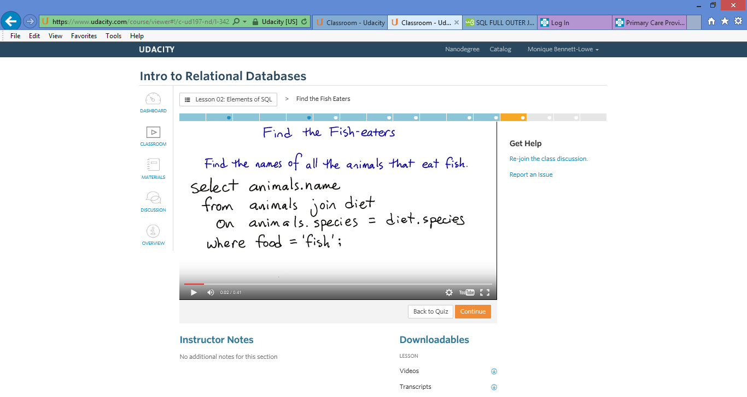

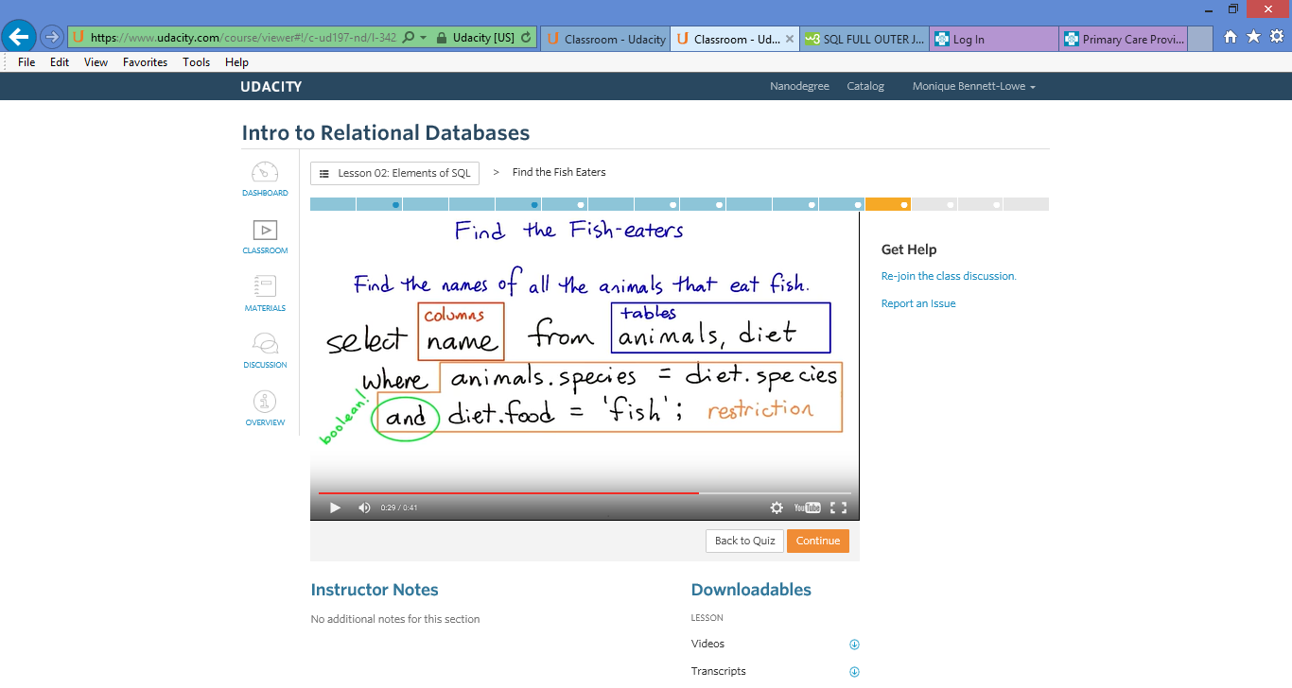
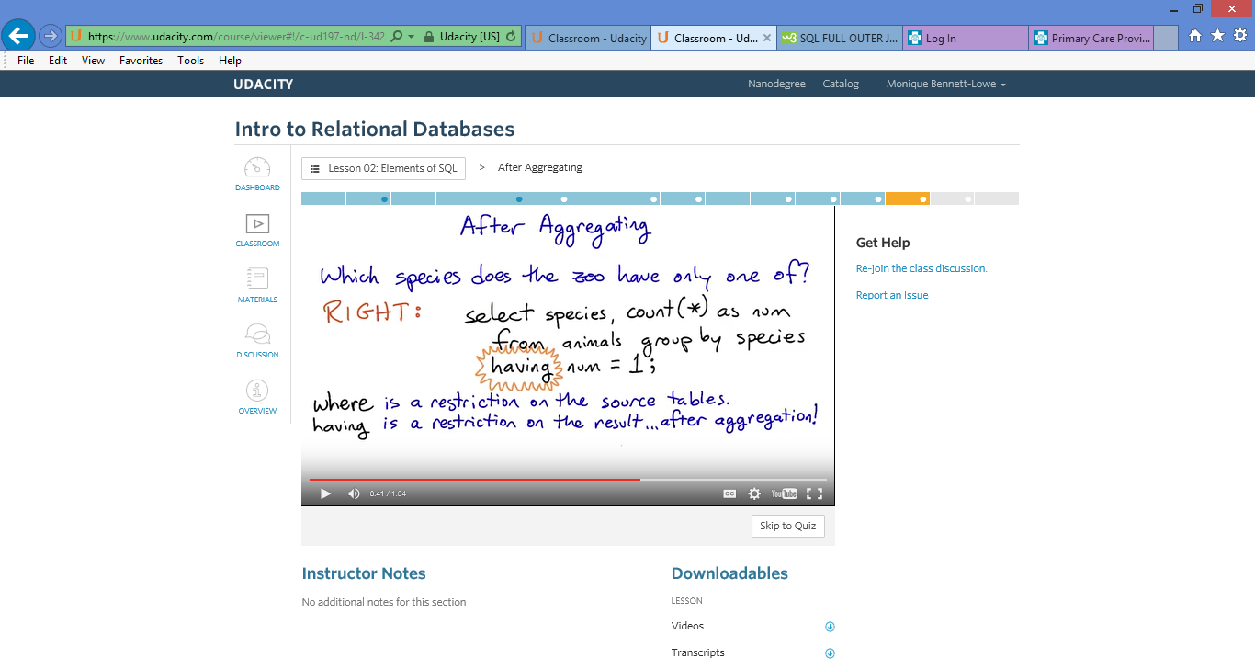

Select food, count (*) as num
from diet
group by species
having num = 1;

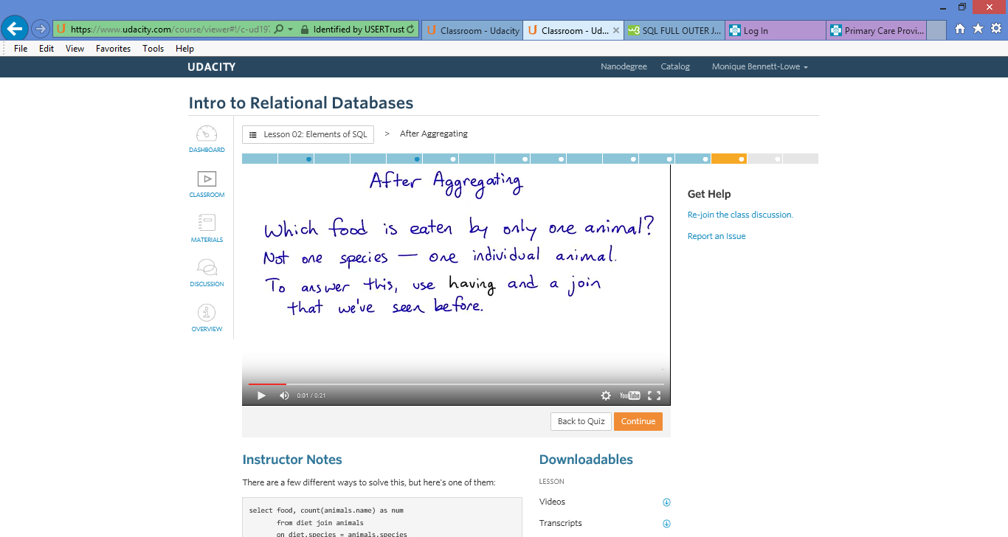
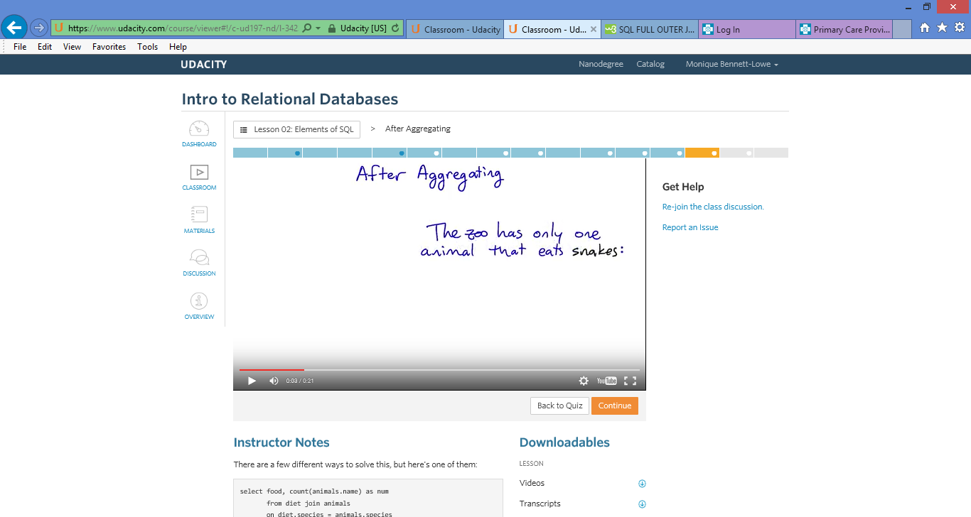

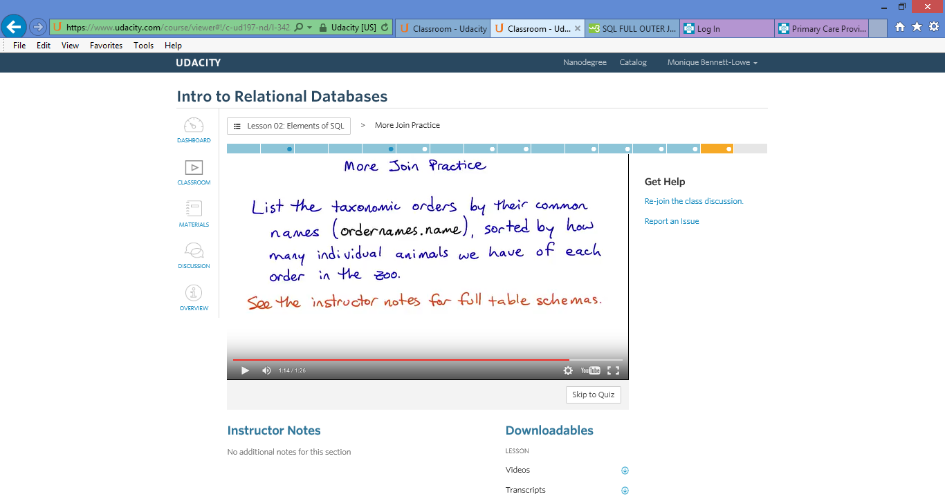
#
# List all the taxonomic orders, using their common names, sorted by the number of
# animals of that order that the zoo has.
#
# The animals table has (name, species, birthdate) for each individual.
# The taxonomy table has (name, species, genus, family, t_order) for each species.
# The ordernames table has (t_order, name) for each order.
#
# Be careful: Each of these tables has a column "name", but they don't have the
# same meaning! animals.name is an animal's individual name. taxonomy.name is
# a species' common name (like 'brown bear'). And ordernames.name is the common
# name of an order (like 'Carnivores').

QUERY = '''
select taxonomy.name
from taxonomy join ordernames
on taxonomy.name = ordernames.name
group by taxonomy.t_order;
'''

Instructor Notes
Here's one possible solution:
select ordernames.name, count(*) as num
from animals, taxonomy, ordernames
where animals.species = taxonomy.name
and taxonomy.t_order = ordernames.t_order
group by ordernames.name
order by num desc
And here's another, this time using the explicit join style:
select ordernames.name, count(*) as num
from (animals join taxonomy
on animals.species = taxonomy.name)
as ani_tax
join ordernames
on ani_tax.t_order = ordernames.t_order
group by ordernames.name
order by num desc
I think the upper version is much more readable than the lower one, because in the explicit join style you have to explicitly tell the database what order to join the tables in — ((a join b) join c) — instead of just letting the database worry about that.
If you're using a more barebones database (like SQLite) there can be a performance benefit to the explicit join style. But in PostgreSQL, the more server-oriented database system we'll be using next lesson, the query planner should optimize away any difference.

